**Design Overview**

Data Flow Diagram Level 0:

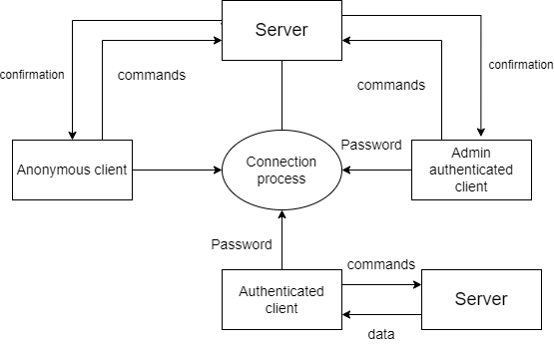

Data Flow Diagram Level 1:

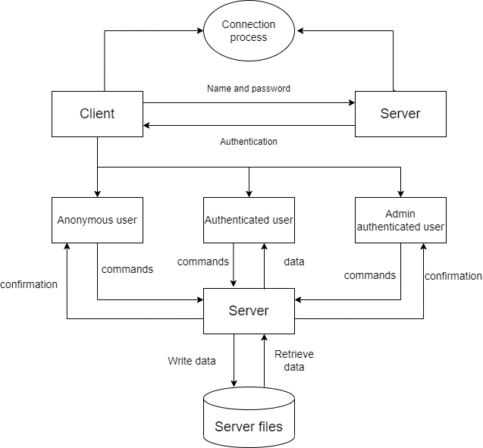

Flowchart for Remote phonebook:

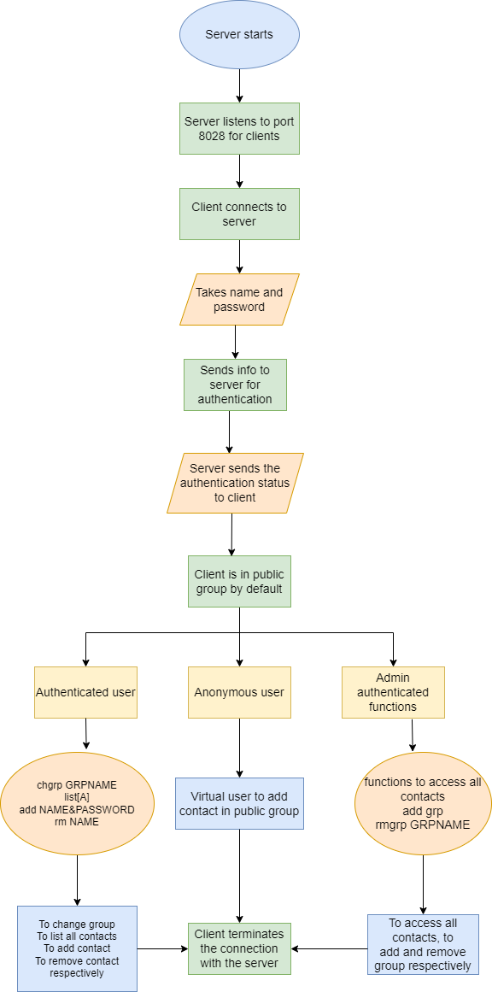

Flowchart for user:

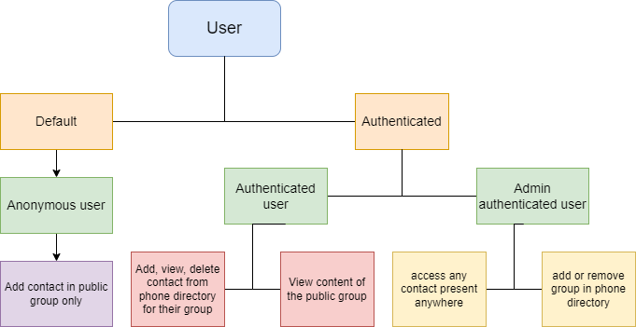

Flowchart for functions of authenticated user:

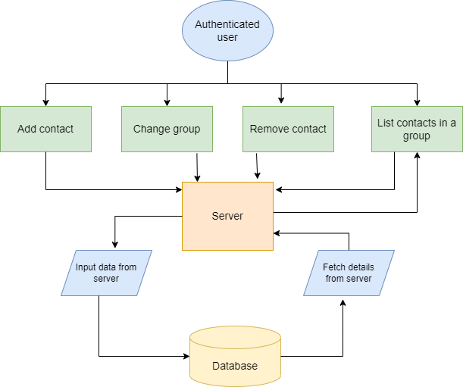

Flowchart for functions for admin authenticated user:

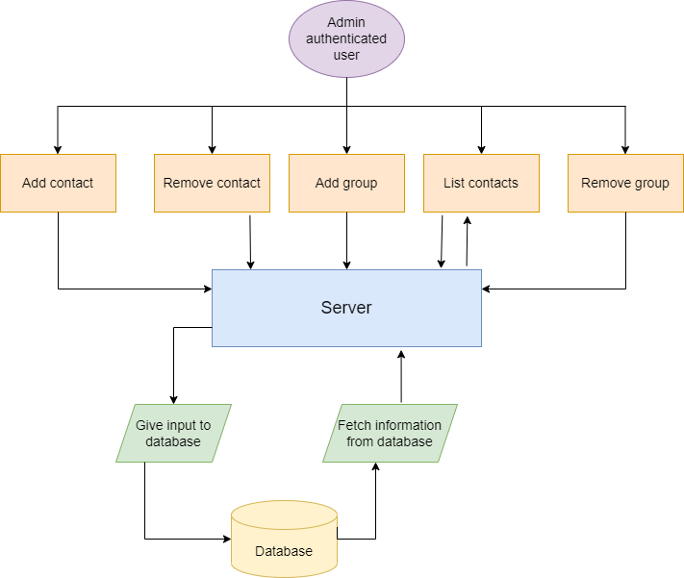

**System Architecture**

Functions:

SERVER FUNCTIONS:

**User Authentication:**

The server should authenticate the user from a poll of registered user data kept with appropriate data structure.

**Server side Firewall Protection:**

The server should listen to port 8028 for client connection and make the client side computer access the server port.

**Service starting at boot:**

The server must configure to start the service automatically at boot.

**Server side concurrency:**

The server should support the concurrent client connection.

CLIENT FUNCTIONS:

**Client side program starting:**

The user should start the client program to connect the Server whenever he wants.

**Client side connection request:**

Client should request a connection to the server on port 8028.

**Client side authentication:**

Client program should start with an authentication

**Client side user environment:**

On successful authentication the user should be placed in a public group for phone book access.

**Client side environment customization:**

Users can use chgrp GRPNAME to change his Working group on phone book.

**Client side browsing contact:**

list[A] to list out all contacts in a group

**Client side contact Add:**

User adds contact using this function.

**Client side contact deletion:**

User can remove any contact from working group

**Client side Group Add and Remove:**

Admin authenticated user use this to add and remove groups.

**Client side quit:**

The user uses the subcommand bye to terminate the connection.